DATA STRUCTURES AND ALGORITHMIC PROBLEM SOLVING PROJECT

Project Title: INTELLIGENT SUPPLY CHAIN MANAGEMENT SYSTEM
Student Name(s): Tharun S
Register Number(s): 26MCAB48
Programme / Class: MCA B
Course Name: Data Structures and Algorithmic Problem Solving
Faculty Guide: Prof. Abinaya S
Department: Kristu Jayanti Institute Of Technology
Academic Year: 2026

1. Abstract
The Intelligent Supply Chain Management System improves how products, inventory, suppliers, warehouses, orders, and deliveries are managed. Manual or poorly organized systems can cause delays, inventory errors, and increased transportation costs.
The system uses Linked Lists for supplier and product data, Queues for order processing, Binary Search Trees (BSTs) for inventory management, and a Graph with BFS (Breadth-First Search) for representing and traversing warehouse and delivery networks. Binary Search helps retrieve supply chain records efficiently.
The Greedy Algorithm is the main algorithmic problem-solving technique used in the system. It selects an efficient warehouse or delivery option by making the best available local choice at each step, helping to reduce delivery distance and transportation cost. The project provides a practical, real-world demonstration of data structures and algorithmic problem solving in supply chain management.

2. Introduction
Background of the Project
Supply chain management covers the movement of products, information, and resources from suppliers to warehouses to customers. As data and operations grow, managing them efficiently becomes harder. This project applies appropriate data structures and a main algorithmic technique to improve supply chain management.
Problem Identified
Manually managed systems struggle with data organization, inventory tracking, order processing, and delivery route selection. Searching and managing large volumes of suppliers, products, warehouses, and orders can become inefficient.
Need for the Proposed System
A structured system is needed to match each type of supply chain data with a suitable data structure. Linked Lists can manage dynamic supplier and product data, Queues can process orders in FIFO order, Binary Search Trees can organize inventory, and Graphs can represent warehouse and delivery connections. Binary Search supports efficient data retrieval.
Overview of the Proposed Solution
The system manages suppliers, products, inventory, warehouses, and orders using Linked Lists, Queues, Binary Search Trees, and Graphs. BFS is used to explore warehouse and delivery network connections, while Binary Search supports data retrieval. The Greedy Algorithm is used as the main algorithmic problem-solving technique for selecting efficient delivery or resource allocation options.

3. Problem Statement
Manually handling supply chain data such as suppliers, products, inventory, orders, and deliveries can lead to tracking difficulties, processing delays, and increased transportation costs.
The project requires a system that manages dynamic data, processes orders in the correct sequence, searches records efficiently, represents warehouse-delivery connections, and selects efficient delivery options.
The proposed system solves these problems by integrating Linked Lists, Queues, Binary Search Trees, Graphs with BFS, Binary Search, and the Greedy Algorithm into one supply chain management application.

4. Objectives
- To manage supplier, product, warehouse, and inventory information efficiently.
- To use Linked Lists for dynamic storage and management of supply chain data.
- To use a Queue for processing customer orders according to the FIFO principle.
- To organize inventory data using a Binary Search Tree (BST).
- To represent warehouses and delivery locations using a Graph data structure.
- To apply BFS (Breadth-First Search) for exploring warehouse and delivery network connections.
- To implement Binary Search for efficient product and inventory searching.
- To use the Greedy Algorithm as the main algorithmic problem-solving technique for selecting efficient delivery or resource allocation options.
- To demonstrate the practical application of data structures and algorithmic problem-solving techniques in a real-world supply chain management system.

5. Proposed System
The system manages and optimizes major supply chain activities — suppliers, products, inventory, warehouses, orders, and deliveries — using suitable data structures and algorithms.
A Linked List handles supplier and product records. A Queue processes orders (first-in, first-out).
A Binary Search Tree (BST) organizes inventory data. A Graph represents warehouses and delivery locations, with BFS exploring the network.
Binary Search locates products or suppliers quickly among sorted records.
Greedy selects efficient delivery options by choosing the nearest suitable warehouse at each step.
Major Functionalities
- Supplier Management — Add, delete, update, and view supplier information.
- Product and Inventory Management — Maintain product details and available stock.
- Order Processing — Manage and process customer orders using a queue.
- Warehouse Management — Organize inventory data using a binary search tree.
- Delivery Network Management — Represent warehouses and delivery locations using graphs.
- Route Exploration — Apply BFS to explore connections between locations.
- Searching — Search for supplier, product, inventory, and order records efficiently.
- Supply Chain Optimization — Apply the Greedy technique to solve warehouse-selection and delivery problems.

6. Data Structures and Algorithms to be Used
The system uses the following data structures and algorithms to manage suppliers, products, inventory, orders, warehouses, and delivery operations efficiently.
A. Linear Data Structures
1. Linked List
Manages dynamic data such as supplier details, product information, and inventory records, without needing a fixed size.
- Insert: Add a new supplier, product, or inventory record.
- Delete: Remove a record when no longer required.
- Traverse: Display and access all records sequentially.
2. Queue Using Linked List
Handles customer order processing using the First-In, First-Out (FIFO) principle — the order placed first is processed first.
B. Hierarchical and Graph Structures
1. Binary Search Tree (BST)
Organizes product or inventory records by a key such as Product ID — smaller values go to the left subtree, larger values to the right — enabling efficient search, insertion, and deletion.
2. Graph Representation
Represents the delivery network: warehouses, suppliers, and delivery locations as vertices, and routes between them as edges. Implemented using an Adjacency List or Adjacency Matrix.
3. BFS (Breadth-First Search)
Explores the network level by level to identify connected locations and possible paths between warehouses and delivery points.
C. Searching
1. Binary Search
Searches sorted data efficiently by repeatedly dividing the search space in two — for example, finding a product by ID.

D. Algorithmic Problem Solving
1. Greedy Technique — Nearest Warehouse Selection
Selects the nearest available warehouse with sufficient stock to fulfil an order, making a locally optimal choice at each step to reduce delivery distance and cost.

7. System / Application Workflow
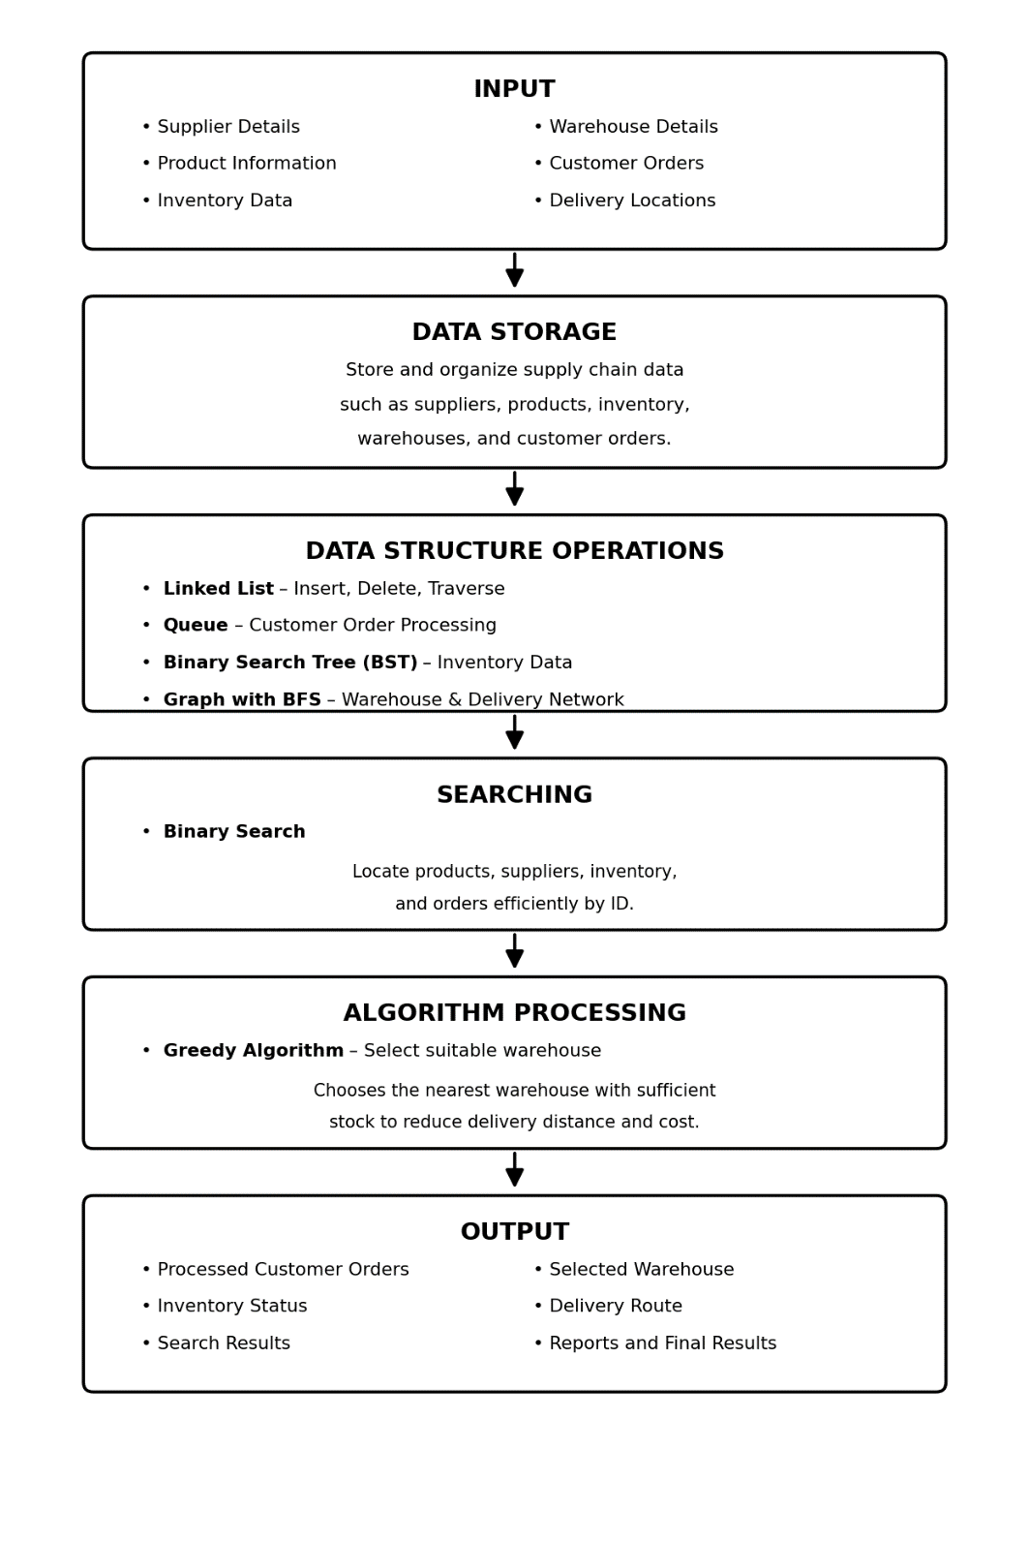

8. Module Description
Module | Description | Data Structure / Algorithm
Module 1: Input / Data Management | Manages supplier, product, inventory, warehouse, and customer order details. Supports adding, deleting, and traversing records. | Linked List
Module 2: Data Processing | Processes customer orders in the order they are received. | Queue
Module 3: Hierarchical Data | Organizes product and inventory records for efficient storage and retrieval. | Binary Search Tree (BST)
Module 4: Graph Processing | Represents warehouses and delivery locations as a network and explores the connections. | Graph with BFS
Module 5: Searching & Sorting | Searches for products, suppliers, inventory, and orders efficiently. | Binary Search
Module 6: Algorithmic Problem Solving | Solves supply chain optimization problems such as warehouse selection and transportation planning. | Greedy Algorithm

9. Proposed Implementation Plan
Phase | Work to be Done
Planning | Identify the requirements, modules, data structures, and algorithms.
System Design | Design the workflow and overall structure of the system.
Data Management | Implement supplier, product, inventory, warehouse, and order management using Linked Lists.
Data Processing | Use a Queue for customer order processing.
Tree Processing | Implement a Binary Search Tree (BST) for organizing inventory and product data.
Graph Processing | Create the delivery network and apply BFS.
Searching | Implement Binary Search for efficient record retrieval.
Algorithm Processing | Apply the Greedy technique for warehouse selection.
Integration | Combine all modules into one application.
Testing | Test all operations and correct errors.
Final Output | Display results and prepare the project documentation.

10. Expected Outcomes
The Intelligent Supply Chain Management System is expected to provide the following outcomes:
- Efficient management of suppliers, products, inventory, warehouses, and customer orders.
- Practical understanding and implementation of Linked Lists, Queues, Trees, and Graphs.
- Efficient processing of customer orders using Queue operations.
- Easy searching of product and inventory records using Binary Search.
- Effective representation of warehouses and delivery locations using Graph structures.
- Exploration of delivery routes using the BFS algorithm.
- Selection of suitable delivery or warehouse options using the Greedy Technique.
- Better understanding of the practical application of data structures and algorithms in solving real-world supply chain problems.

11. Tools and Technologies
Tool / Technology | Purpose
Frontend | HTML, CSS, JavaScript
Backend / Programming Language | Python
Framework | Flask
Database | MySQL
IDE / Development Environment | Antigravity
Database Connectivity | MySQL Connector for Python
Data Structures | Linked List, Queue, Binary Search Tree (BST), Graph
Algorithms | BFS, Binary Search, Greedy Algorithm

12. Future Enhancement
The Intelligent Supply Chain Management System can be enhanced in the future by adding more advanced features such as:
- Real-time inventory tracking and automatic stock updates.
- GPS-based tracking for delivery vehicles.
- Advanced route optimization using real-time traffic data.
- Demand prediction using Machine Learning techniques.
- Automatic alerts for low inventory and delayed deliveries.
- Integration with online ordering and supplier systems.
- Cloud-based storage for accessing the system from multiple locations.
- A mobile application for warehouse managers and delivery personnel.
- Dashboard and graphical reports for better analysis and decision-making.
- AI-based recommendations for inventory management and supplier selection.

13. References
- Goodrich, M. T., Tamassia, R., & Goldwasser, M. H. Data Structures and Algorithms in Python. Wiley.
- Cormen, T. H., Leiserson, C. E., Rivest, R. L., & Stein, C. Introduction to Algorithms. MIT Press.
- Python Software Foundation. Python Documentation.
- GeeksforGeeks. Data Structures and Algorithms.
- TutorialsPoint. Data Structures and Algorithms.
- Course materials and lecture notes for Data Structures and Algorithmic Problem Solving.

